November 24, 2014 www.ISRISafety.org
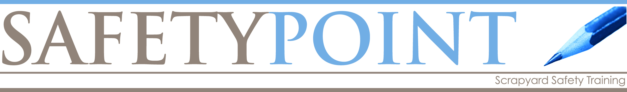

Welding Safety FAQs - Electric Shock
Q: What voltages are used in the arc welding process?
A: Arc welding involves open circuit (when not welding) voltages which are typically from as low as 20 volts to as high as 100 volts.
Q: What voltages are normally found inside the case of an arc welder?
A: The voltage inside welding equipment is commonly much higher: from 120 volts to 575 volts or more.
Q: When can you receive a primary voltage electric shock?
A: You can receive a shock from the primary (input) voltage if you: touch a lead or other electrically "hot" component inside the welder while you have your body or hand on the welder case or other grounded metal with the power to the welder "on."
Q: What is the purpose for grounding the case of an arc welder?
A: The case must be grounded so that if a problem develops inside the welder a fuse will blow, disconnecting the power and letting you know that repair is required.
Q: How can you identify the grounding lead in the input power cable?
A: The input power grounding lead has green insulation or may have no insulation at all.
Q: What is the difference between the work lead and the grounding lead?
A: The Green Grounding Lead used to connect the welder to earth ground is not the same as the Work Cable (sometimes called the "Welding Ground Cable") which is part of the arc welding circuit and only carries welding current. The Work Cable does not Ground the welder case.
Q: What must occur for you to get a secondary voltage electric shock?
A: A secondary voltage electric shock occurs when you touch a part of the welding or electrode circuit - perhaps a bare spot on the electrode cable at the same time another part of your body is touching the metal upon which you're welding (work). To receive a shock, your body must touch both sides of the welding circuit, electrode and work (or welding ground) at the same time when the welding output is on.
Q: When is the voltage at the electrode the highest?
A: The voltage at the electrode is highest when you are not welding (open circuit voltage).
Q: How do you protect yourself from electric shock when welding?
A: Insulate your body from the metal you are welding. Don not rest you body, arms, or legs on the work piece (the metal being welded), especially if your clothing is wet or bare skin is exposed (and it should not be if you are dressed properly). Use plywood, rubber mats or some other dry insulation to stand or lie upon. Wear dry gloves in good condition when welding. Do not touch the electrode or metal parts of the electrode holder with skin or wet clothing.
Q: Under what conditions is arc welding electrically hazardous?
A: A situation can be electrically hazardous if welding must be performed under electrically hazardous conditions (in damp locations or while wearing wet clothing, on metal structures such as floors, gratings or scaffolds, when in cramped positions such as sitting, kneeling or lying, or if there is a high risk of unavoidable or accidental contact with the work piece or ground).
Q: What type of welding equipment is best suited for arc welding under electrically hazardous conditions?
A: Semiautomatic DC Constant Voltage welder, DC Manual (stick) welder or AC welder with Reduced Voltage Control.
Q: What should you do if you receive an electric shock?
A: If you experience an electric shock under any circumstances, think of it as a warning. Check your equipment, work habits and work area to see what is wrong before continuing to weld. See your physician immediately.
Q: What should you do if you think something is wrong with your welder?
A: If you think something is wrong, disconnect input power from the welder and report the problem to your supervisor or to a Qualified Electrician. Do not use the welder again until it has been checked.

