November 17, 2014 www.ISRISafety.org

Real Fall Protection Solutions
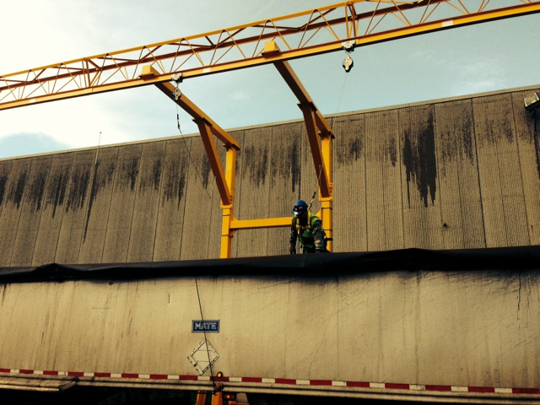

Real fall protection solutions are out there. There’s no good reason in today’s world for scrap yard workers to walk trailers or rail cars without effective fall protection. For more information on solutions like these, contact isrisafety.org.

