July 14, 2014 www.ISRISafety.org
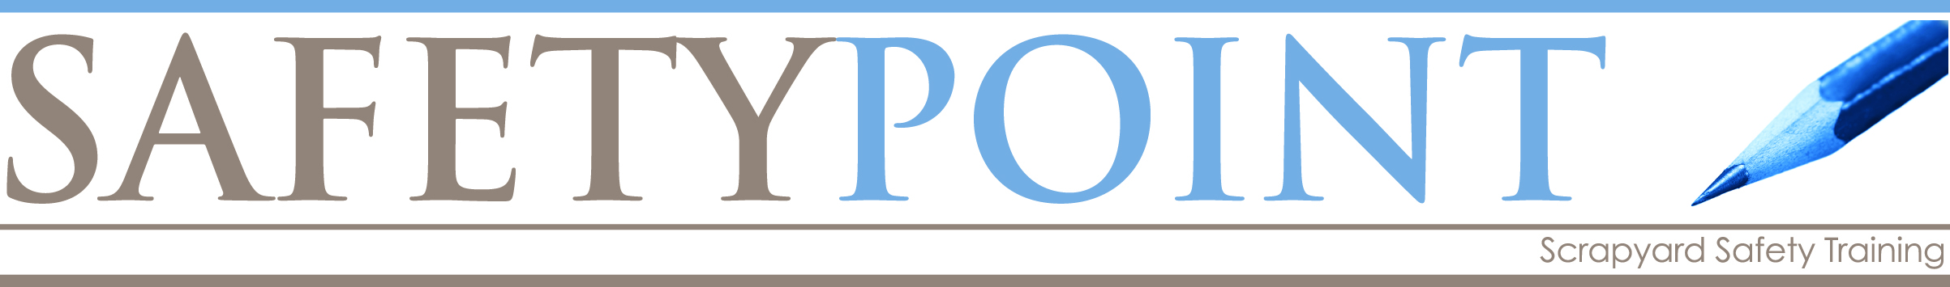

Fall Protection: In the Air

You’ve got to be tied off with full body harness and lanyard
in a man basket on a forklift
AND in an aerial lift:

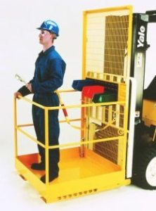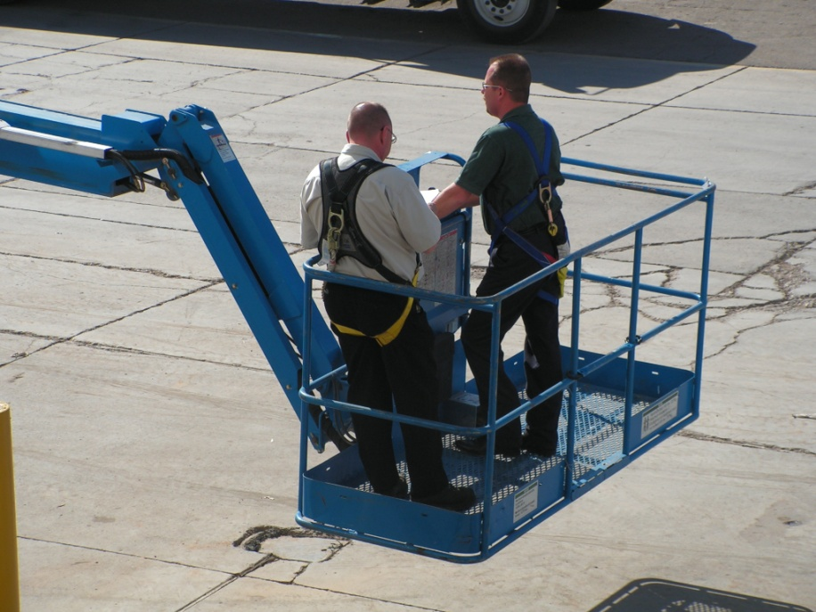

OSHA recently cited a scrap recycler for having a homemade man basket.
What about yours? Was it designed by an engineer to hold a human being,
or was it made to hold something else?

If you’re using a man basket on a forklift, is this part of your forklift operator training? If not, make it that way now. That forklift operator is holding that man’s life in his hands. Is he up to this responsibility?

