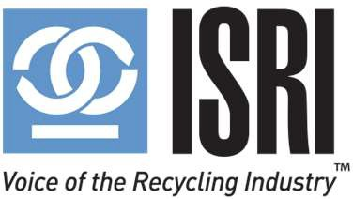
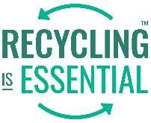
ISRI is the voice of the recycling industry, promoting safe, economically sustainable and environmentally responsible recycling through networking, advocacy and education.

ISRI Winter 2023 Committees & Board of Directors Meetings

Education and Training Committee Meeting

Thursday, January 12, 2023
2:15 – 3:15 PM ET | Virtual

AGENDA

- Welcome, Antitrust Message, Safety Message, and Introductions

- Approval of October 26, 2022, Meeting Minutes

- 2022 - The Year in Review

- 2023 Online Programming
    - Webinars
      - Jan 25: ISRI’s Reasonable Care Compliance Program: An Intro to SREA (Superfund Recycling Equity Act) & Its Connection to the Industry’s Biggest Challenges (Members only)
      - March 15: Davis Index sponsored webinar - Ferrous Market update

    - SafetySkills Courses - Forklift Operator Training in Safety

- 2023 Programming
    - ISRI Industry Leadership Development Program – program content

- Workforce Development Committee Update

- Old or New Business Open Forum

- Adjourn

Next Meeting: ISRI 2023 Spring Meeting will be Monday, April 17 from 11:00 AM -12:00 PM, room 205 A-B - Level 2 (subject to change) at Music City Center, Nashville, TN.

Co- Chairs: Marvin Finkelstein and Nidhi Turakhia
Executive Committee Liaison: Gary Champlin Staff Liaison: Paula Pagano

